College Database Activity
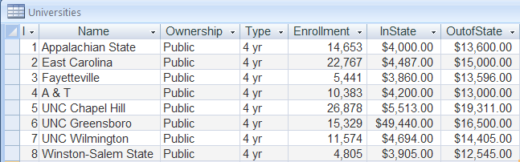

    - What are the field names?
    - What is the name of the table?
    - How many records are there?
    - How many entries are there?
    - Describe the contents of one record.
Describe the contents of one field.

