Fun with Basic Formulas & Functions
Directions: Practice using functions to write formulas for the following 10 statements and answer the questions that follow.

Practice using formulas and functions for the items below
1 |  | Add the range of cells A1:B10
2 |  | Divide A2 by the sum of the range of cells in A10 through C10
3 |  | Find the highest number in the cell range A1:C10
4 |  | Subtract B8 from the sum of cells C1 through C10
5 |  | Multiply A6 by the sum of cells A1 through C10 and then divide the result by A2
6 |  | Find the lowest number in the cell range A1:A10
7 |  | Calculate the average of cells C1:C10
8 |  | Multiply the sum of the range of cells A7 through B10 by the sum of the range of cells B2 through C9
9 |  | Find the average of all data in the spreadsheet (A1:C10)
10 |  | Subtract C10 from the sum of the cells in the range A1 through A10

- Open a new blank spreadsheet and enter the data in Table 1 (below) in the exact cell locations as shown. Try out your formulas by keying them in Cells D1:D10 of the spreadsheet you just created. Check the accuracy of your work against the answers in Column D of Table 2 (below).
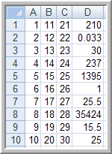
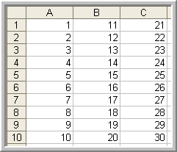
Table 2 Did you achieve the same results as those in Column D?
Table 1
Enter these numbers in a new spreadsheet

- What items gave you trouble?

- What tips can you share that make using basic function writing easy?

- How might you use a spreadsheet to verify your formulas?

- What should you do if you can’t get a formula to work correctly?

