Independent Practice: Spreadsheet Formatting
In this exercise, you will complete the following tasks independently:

- Format a header
- Use a simple formula
- Copy data
- Apply font styles
- Adjust column and row size
- Wrap text
- Indent cell data
- Format values
- Add a border

- Open a new spreadsheet
- Set a header with your name in the left section, the current date in the center, and the filename assigned to this exercise by your teacher in the right section.
- Key the data shown in the table below in the exact cell locations
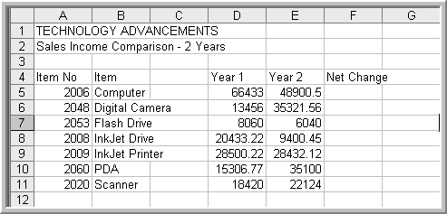

- Merge and center the title cells for Technology Advancements in all caps and bold across Columns A-F
- Merge and center the sub-title Sales Income Comparison-2 Years in initial caps and bold across Columns A-F
- Adjust all column widths to fit contents
- Center all data in Row 4 and in cell range A5:A11
- Format the data in Columns D and E for two decimal places
- Change the title in A4 from Item No to Item Number
- Wrap the text in A4
- Merge and center the heading in B4 across Columns B and C
- Replace “Drive” with “Cartridge” in Cell B8
- Enter a formula in Cell F5 that will calculate Net Change
  - What is the formula?

- Copy the formula to the remaining cells in Column F and format for 2 decimal places

- Which items experienced negative growth? How do you know?

- Add and indent the word Total in Cell A12
- Use a formula to calculate the total net change in Cell F12 and format it for currency.
What formula did you use?

- Add a single line bottom border to Row 4, Columns A-F
- Add an accounting border to Cell F12
- Save and submit according to teacher directions

