Independent Practice: Spreadsheet Operations

In this exercise, you will work independently to use print preview and print a selection

- Open a new spreadsheet
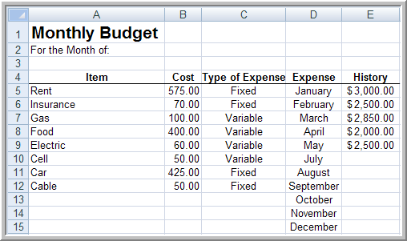
- Key the title in 16 point bold
- Key and center the column headings using bold font
- Format a single line border underneath the column headings
- Format the values in Column B for 2 decimal places
- Center the data in Column C
- Use auto-fill to enter the months in Column D and center the data
- Format the amounts in Column E as currency
- Merge and center Monthly Budget across Columns A-E
- Merge Cells A2 and B2and and right justify the data
- Use the wrap text feature where appropriate (in column headings)
- Key June in Cell C2
- Key Total Expenses in bold font and initial caps in Cell A16
- Enter a formula in Cell B16 to calculate total expenses
- Delete Column D
- Sort the data by Type of Expense in ascending order (primary) and then by item (secondary)
- Print the data in Columns A-C in horizontally centered format without checking gridlines or row and column headings
- Save and submit according to teacher directions

