Practice with IF Statements
Part I Directions: Write an IF statement for each condition. The first has been completed for you. For number 10, write your own condition and IF Statement.
 | Condition | IF Statement
 | IF A2 is equal to “Feline”, write “Cat” in B2, otherwise, write “Amphibian” | =IF(A2=”Feline”,”Cat”,”Amphibian”)
 | IF A5 is equal to “Carrot”, write “Vegetable” in B5, otherwise, write “Mineral”
 | IF A8 is equal to “Explorer”, write “SUV”, otherwise, write “Sedan”
 | IF A11 is equal to “Deli”, copy the contents of A11, otherwise, enter 0
 | IF A14 is greater that 0, multiply A14 by 8, otherwise, enter 0
 | IF A17 is equal to 1, enter “True”, otherwise, enter “False”
 | IF A20 is equal to 0, enter “Off”, otherwise, enter “On”
 | IF A23 is greater than 0, multiply A23 by 15, otherwise, enter 0
 | IF A26 is equal to “Adult”, multiply B26 by 8.50, otherwise, multiply B26 by 5

Practice with IF Statements
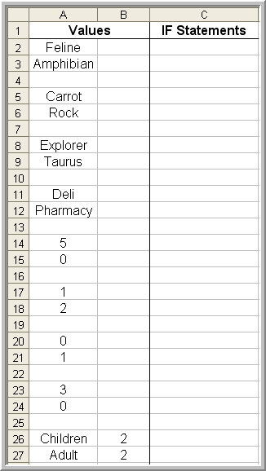
Part II Directions:
- Open a new spreadsheet and key the data in the exact locations as shown in the spreadsheet example on the right
- In Cell C2, enter the IF statement you wrote for Condition 1 in Part I of this activity
- Copy the IF statement in Cell C2 to Cell C3
- In Cell C5, enter the IF statement you wrote for Condition 2 in Part I of this activity
- Copy the IF statement in Cell C5 to Cell C6
- Continue entering the IF statements you wrote in the appropriate cell locations for all of the remaining conditions in Part I
- Think about the answers that appear and rework any statements that do not return accurate results
- To view the spreadsheet in formula view, hold down the control key and press the tilde (~)

